|  |
| --- |
|  |
| **System design document**  System Engineering**-**Gruppe E |
| **Design Specification for MWS Pod** |
| Prepared for: |
| Company A |
| By: Company E (Anders Torndahl, Christian Jensen, David Neergaard Rasmussen Marmoy, Pedersen, Peter Høgh Mikkelsen) |
|  |

|  |  |
| --- | --- |
| Table of Contents  1 Version History 2  2 Scope 2  2.1 System overview 2  2.2 Document Overview 3  3 Referenced Documents 3  4 System-wide design decisions 4  4.1 Functional System Behaviour 4  4.2 Non-Functional System Behaviour 4  5 System architectural design 4  5.1 System components 4  5.1.1 Identify components 4  5.1.2 Static Depiction of Component Relationships 5  5.1.3 Purpose 6  5.2 Conceptual Build-up 7  6 Requirements Traceability 8  7 Budget 9  7.1 Development Costs 9  7.2 Pod Structure Production Costs 10 | |
| System design document | |
| Project: | $System Engineering**-**Gruppe E |
| Revision: | $Revision: 1.0 $ $Date: 071010 $ |
| Document: | $ |
| Copyright (c) 2010 by Systematic Group. It shall not be copied, reproduced, disclosed or otherwise made available to third party without previous consent from Systematic Group | |

# Version History

|  |  |  |  |
| --- | --- | --- | --- |
| **Version #** | **Date** | **Name** | **Change** |
| 0.1 | Oct 7, 2010 | PHM | Document creation |
| 0.2 | Oct 8, 2010 | PHM | Pod structure added |
| 0.3 | Oct 10, 2010 | PHM | Release for internal review |
| 0.4 | Oct 10, 2010 | PHM | Interface design updated according to review |
| 1.0 | Oct 10, 2010 | PHM | Initial Release |

# Scope

## System overview

The EWS Pod is a self-protection unit for F-16 aircraft. The pod has sensors to warn the pilot of any incoming threats and magazines for dispensing chaff or flares to divert the incoming threat. The system may run fully autonomous without pilot intervention, thus giving an excellent protection.

The Pod itself is the casing holding all the major components of the self-protection system. It is mounted under the left wing using the standard weapons mechanical interlock.

The scope of this document is the Pod mechanics.



Figure 1 MWS Block Definition Diagram

Pod is carried at positions 3 or 4.

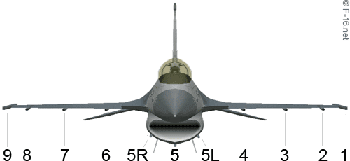

Figure 2 F-16 Payload Mounting Points

## Document Overview

The scope of the document is to describe the solution to the ”Pod Structure Requirement Specification” provided by Company A.

The document describes the following:

***Referenced documents*** - Lists the titles and version numbers of documents referenced in this document.

***System-wide design decisions*** – Presents decisions about the system’s behavioral design (how it will behave, from a user’s point of view, in meeting its requirements, ignoring internal implementation) and other decisions affecting the selection and design of system components.

***System architectural design*** – Which is divided into the subsections:

***System components***Identifies the components of the system, shows the static relationship(s) of the components. States the purpose of each component and identifies their development status/type.

***Concept of execution***Describes the concept of execution among the system components. It includes diagrams and descriptions showing the dynamic relationship of the components, that is, how they will interact during system operation.

***Interface design***Identifies and describes both interfaces among the components and their interfaces with external entities such as other systems, configuration items, and users.

***Requirements traceability*** – References traceability matrix, specifying the relationship between the system requirements and system components.

# Referenced Documents

[1] “Subsystem Requirement Specification: Pod Structure” Version 0.3 by Company A

[2] “Terma Case”, Version 1.4 by Terma

# System-wide design decisions

## Functional System Behaviour

*Climate Control Unit is NOT equipped*. Room is kept at the back of the Pod for a future climate control upgrade, it is however not included in this release.

*One safety-lock per magazine*. To minimize the number failure modes, the safety locks are simple, mechanical, one-per-magazine splits with banner flags attached.

*Magazine reload without disassembly*. The dispense openings are designed to allow magazines to be reloaded without Pod disassembly. This ensures short reloading time.

## Non-Functional System Behaviour

*Positioning of magazines is static*. To lower weight, keep ruggedness and optimize physical stability, it has been decided that the magazine positioning can NOT be adjusted.

*Heat transfer infrastructure is embedded in the Pod structure*. Heat pipes will be embedded in the structure for transporting passive cooling from the rear of the Pod (apt).

*Electrical interconnect is to be decided*. The means of electrical interconnect is not considered. Simple cable openings are provided.

# System architectural design

## System components

### Identify components

Pod Structure id: component0101

PCU id: component0102

MWS id: component0103

Standard Magazine id: component0104

Safety Interlock id: component0105

Chassis id: component0106

Body id: component0107

Attachment System id: component0108

Heat Transfer System id: component0109

### Static Depiction of Component Relationships



Figure 3 EWS Electrical Interface Block Diagram



Figure 4 EWS Mechanical Interface Block Diagram

### Purpose

#### Component0101 Pod Structure

Covers the complete Pod structure and is the top-level mechanical component.

#### Component0102 PCU

The Power Conditioning Unit is a COTS product supplied by Terma. The PCU unit will be bolted to the chassis.

#### Component0103 MWS

The central unit for coordinating sensor inputs, pilot notifications and chaff/flare dispension. This product is supplied by Terma. The MWS unit will be bolted to the chassis.

#### Component0104 Standard Magazine

The magazines are COTS products supplied by Terma. They will be fitted into a designated holder.

#### Component0105 Safety Interlock

The safety interlock splits, are ø8 mm steel splits, attached with a 20cm banner flag, holding the text “Remove before flight”.

#### Component0106 Chassis

The chassis consists of an aluminium frame with necessary reinforcement. The chassis is optimized for weight, g-force and heat transport.

#### Component0107 Body

The body is designed to withstand air pressure and temperatures as described. Effort is put into minimizing air resistance and optimizing storage capacity.

#### Component0108 Attachment System

The Pod is attached using standard T-hooks. The attachment system ensures safe attachment and seals the openings between wing and Pod to protect electrical wires etc.

#### Component0109 Heat Transfer System

Build into the chassis, the heat transfer system removes heat from the critical units (PCU, MWS, DSS) by means of convection. A radiator is mounted at the back of the Pod to let the slip stream provide cooling.

## Conceptual Build-up

This initial design focus on creating a well-distributed system. It encompasses the requirements and creates a product with exceptional weight balance and thermal performance. The slip stream is used for passive cooling of the embodied heat transfer system. Magazines are positioned to minimize interference with existing weapons systems.

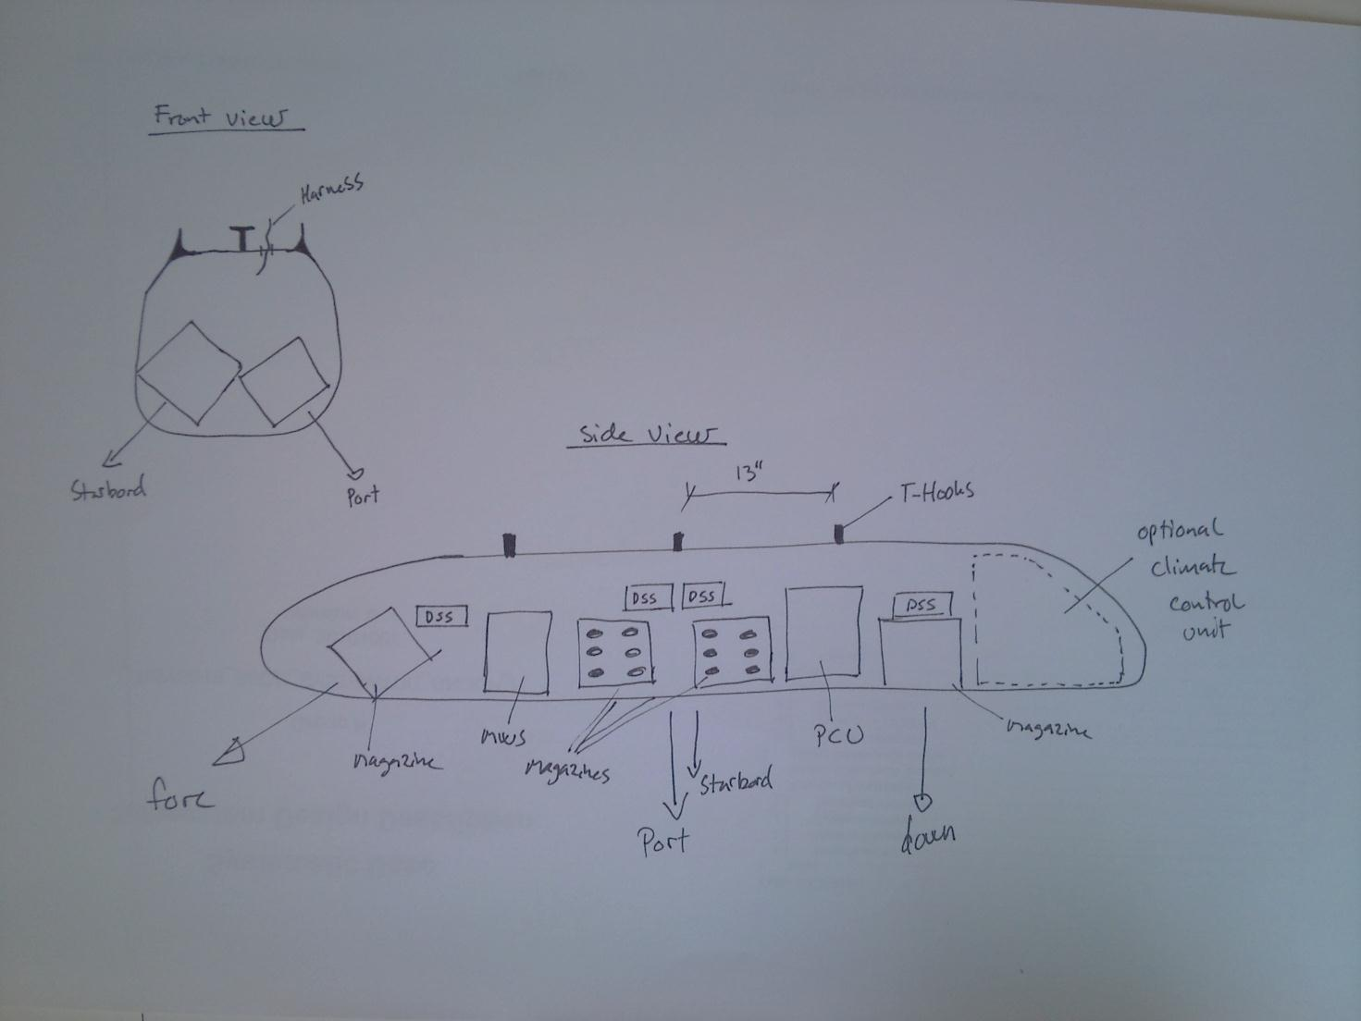

Figure 5 Conceptual Pod Build-Up

# Requirements Traceability

|  |  |  |
| --- | --- | --- |
| Requirement ID | Level | Description |
| SS-POD-RQ-1 | Physical | The Pod chassis provides fixture for two standard magazines in fore, port, starbord and down directions |
| SS-POD-RQ-2 | Physical | The dispense openings are designed to provide easy magazine reload |
| SS-POD-RQ-3 | Physical | One mechanical safety interlock is provided per magazine |
| SS-POD-RQ-4 | Physical | Standard T-hooks are used for pod attachment |
| SS-POD-RQ-5 | Physical | Provisions are made for cable entries |
| SS-POD-RQ-6 | Physical | Provisions are made for cable entries |
| SS-POD-RQ-7 | Physical | Provisions are made for cable entries |
| SS-POD-RQ-8 | Physical | The Pod will be made of lightweight material in a very static monocoque design. Keeping the weight at a minimum |
| SS-POD-RQ-9 | Physical | The structure will be made large enough to encompass all key components as well as room for a future climate conditioning update. |
| SS-POD-RQ-10 | Physical | Size, shape, firing angle and sensor location are adapted according to existing weapons systems |
| SS-POD-RQ-11 | Physical | The structure is designed, simulated and tested to carry 100 Kg at the g-levels specified |
| SS-POD-RQ-12 | Environment | Structure will be designed to fulfill acceleration requirements |
| SS-POD-RQ-13 | Environment | The pod is equipped with heat pipes that are cooled by convection at the back of the Pod. Active cooling is not provided in this revision |
| SS-POD-RQ-14 | Environment | Insulation is provided to protect interior. Exterior is protected by design |
| SS-POD-RQ-15 | Environment | Insulation is provided to protect interior. Exterior is protected by design |

# Budget

## Development Costs

*1. Iteration*

Engineering…………………………………………………………… DKK 1.000.000

Mock-ups……………………………………………………………… DKK 1.100.000

Testing…………………………………………………………………. DKK 150.000

Total……………………………………………………………………… DKK 2.250.000

*2. Iteration*

Re-design……………………………………………………………… DKK 150.000

Proto type build…………………………………………………… DKK 1.500.000

Mechanical Tests…………………………………………………… DKK 100.000

Validation by Authorities……………………………………… DKK 150.000

Total……………………………………………………………………… DKK 1.900.000

*3. Iteration*

Re-design……………………………………………………………… DKK 100.000

Flight Version Build……………………………………………… DKK 1.800.000

Mechanical Tests…………………………………………………… DKK 100.000

Flight Tests…………………………………………………………… DKK 100.000

Final Validation by Authorities……………………………… DKK 150.000

Total……………………………………………………………………… DKK 2.250.000

Pod Structure Development Costs*……………………… DKK 6.400.000

(*) Including mock-up, prototype and flight versions

## Pod Structure Production Costs

Mounting Posts……………………………………………………… DKK 15.000

Chassis…………………………………………………………………… DKK 250.000

Body……………………………………………………………………… DKK 200.000

Support Structure………………………………………………… DKK 200.000

Insulation……………………………………………………………… DKK 100.000

Heat Transport……………………………………………………… DKK 50.000

Surface Treatment / Paint…………………………………… DKK 50.000

Work……………………………………………………………………… DKK 700.000

**Total……………………………………………………… DKK 1.565.000**